**SPRINT 4**

|  |  |
| --- | --- |
| **Team ID** | PNT2022TMID23716 |
| **Project Name** | Smart Fashion Recommender Application |

**UPLOAD IMAGE TO IBM CONTAINER REGISTRY:**

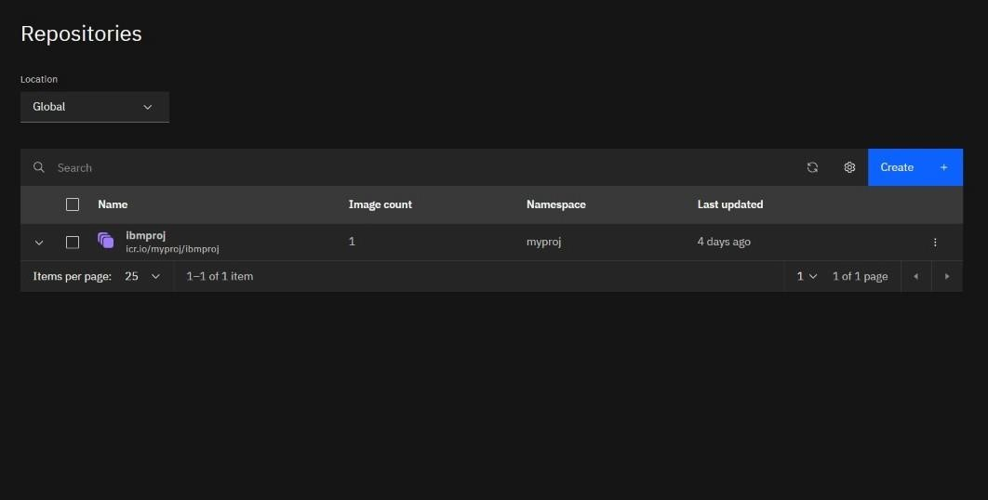

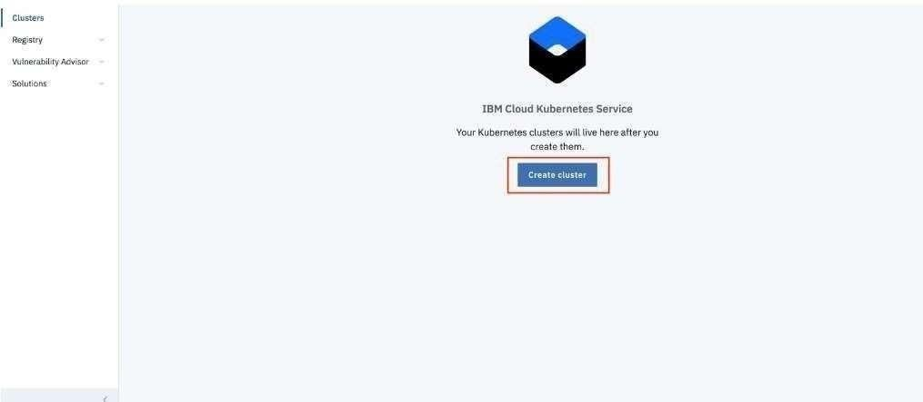

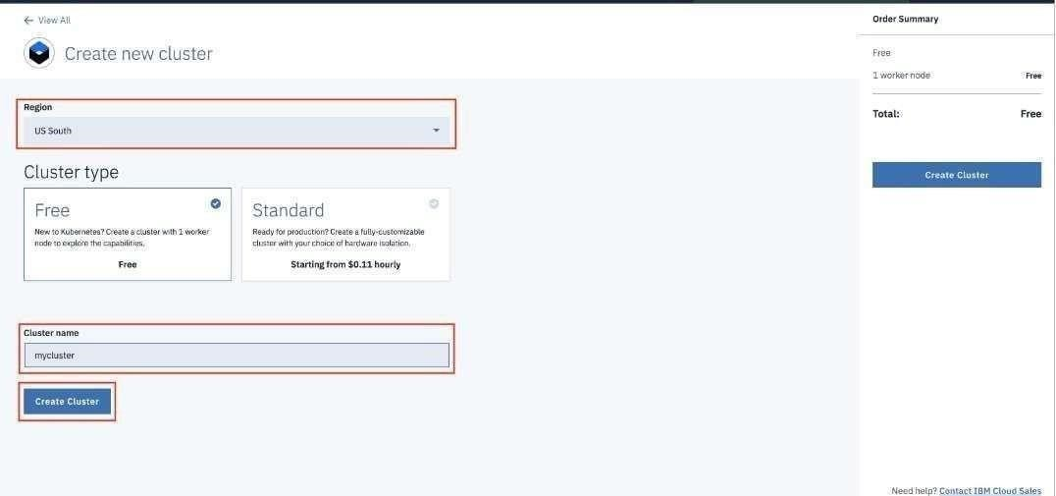

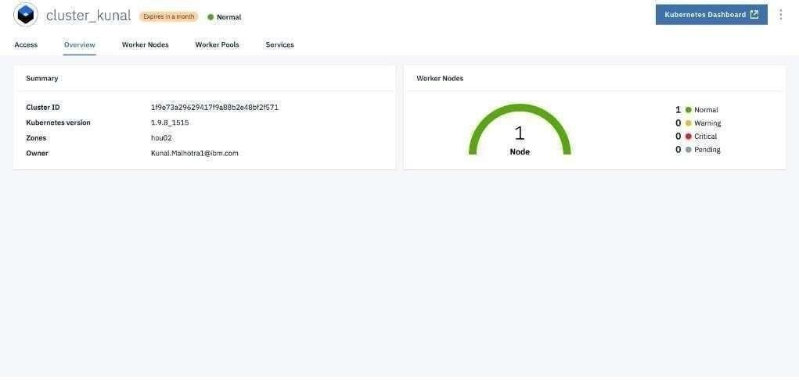

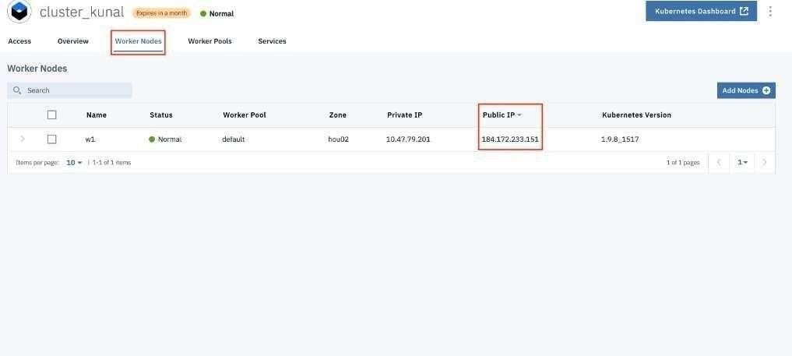

**DEPLOY IN KUBERNETES CLUSTER:**

